Optimal Number of Clusters

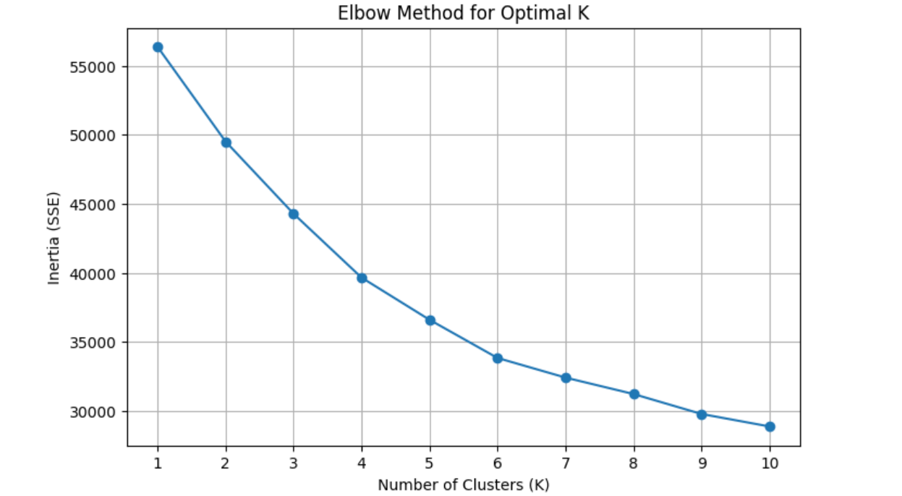

We used the **Elbow Method** to find the best number of clusters for K-Means. When we looked at the plot, we saw that the **inertia (error)** dropped quickly from K=1 to K=4. After K=4, the drop became much smaller.

This means that **K=4** is the best choice. It gives us good clusters without making the model too complex.